covid-19 VACCINES ANALYSIS

BATCH MEMBER

* 732521104701: SRUSHTY A

PHASE 4 SUBMISSION DOCUMENT

PROJECT TITLE: COVID19 VACCINES ANALYSIS

PHASE 4: DEVELOPMENT PART 2

TOPIC

Continue conducting the Covid-19 vaccines analysis by:

* Performing exploratory data analysis
* Statistical analysiS
* Visualization.



COVID 19 VACCINES ANALYSIS

INTRODUCATION;

* On December 31, 2019, a novel corona virus disease caused by severe acute respiratory syndrome type 2 corona virus (SARS-CoV-2) was first reported in China.
* On January 30, 2020, the World Health Organization (WHO) announced that the new corona virus pneumonia epidemic was listed as a "public health emergency of international concern," and on February 11, the WHO officially named the disease as Corona virus disease 2019 (COVID-19).COVID-19 had a devastating impact on almost all countries in the world
* Because the new corona virus is highly contagious and spreads quickly, it is not easy to find in mild cases and asymptomatic infections.
* Also, it is easy to cause "hidden" transmission in communities and medical institutions. The virus may gradually evolve into a seasonal low-level epidemic.
* Even if the virus can be completely eliminated from the population, the transmission mechanism from the host to the person is still unclear due to the population's general susceptibility.
* There is a risk of recurrence or periodic epidemics. Vaccines need to be administered as soon as possible. Globally, 7.8 billion people are at risk of SARS-CoV-2 infection and the morbidity and death of COVID-19. People are looking forward to developing an effective and safe COVID-19 vaccine to contain this COVID-19 pandemic and prevent another outbreak of the epidemic.
* More than 200 COVID-19 vaccines have been listed in the WHO as under development. The expectations for effective prophylactic COVID-19 vaccines are very high

Performing exploratory data analysis:

Perfoming an exploratory data analysis (eda) on covid 19 vaccines data can provid insights into its distributed effectiveness,and other important factors

Here’s a simplified step-by-step guide on how you might approach this:

* Data collection:obtain a reliable dataset with covid 19 vaccine information such as vaccination rates ,vaccine types and demographic data

2.data cleaning: remove duplicates and missing values

* Convert data types as needed
* Handle outliers and anomalies

3.descriptive statistics:

* Calculate basic statistics like mans ,median ,standard deviation
* Create summary tables and visualization to get a sense of the data

4.visualization:

* Plot histogram for vaccine distributed
* Create bar charts to compare vaccine types or manufactures

5.correlation analysis

* Use correlation coefficients and scayyer plots to visualize these relationship

6.time series analysis:

* If you hava data over time analyze trends and seasonality in vaccination rates

7.hypothesis testing:

* Test hypothesis related to vaccine efficacy

8.geospatial analysis

* If you have geograpic data perform spatial analysis

9.machine learning;

* If you have enough data perform predictive models to forecast future vaccination rates

10.interpretation

* Provide meaningful insihts and conclusion from your analysis.

Statistical analysis

* Covid 19 vaccines data involves more rigorous quantitative methods:

1.data collection and preparation

2.descriptive statistics

3.hypothesis testing

4.correlation and regression analysis

5.survival analysis

6.statistical modeling

7.statistical software

8.data visualization

9.statistical significance

10.reporting and interpretation

11.peer review.

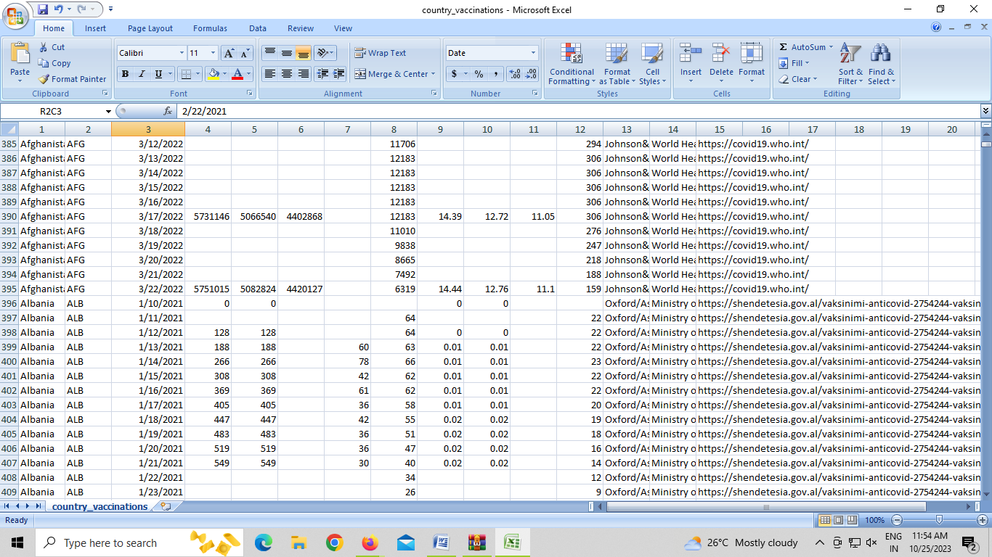

Visualization:

Visualizing covid 19 vaccine data is a powerful way to convey information and insights

* Some types of visualization you can create

1.Vaccine distribution:

A bar chart or pie chart showing the distribution of different covid 19 vaccines administered

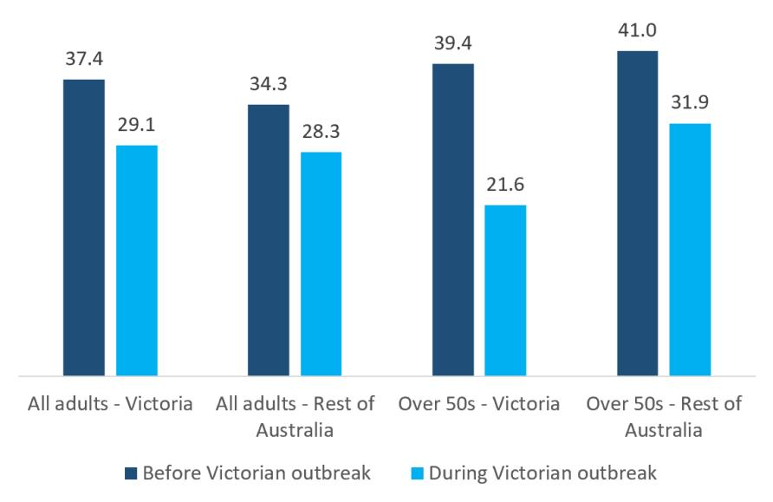

2.vaccination rates:

* Use chorpleth maps to visualize vaccination rates by region country or stste.

3.demographic breakdown:

* Generate bar charts or pie charts to illustrate the demographic breakdown of vaccine recipients by age,gender,or ethnicity

4.time series analysis

* plot time series data to show how vaccination rates or cases have evolvrd over time

5.vaccine efficacy:

* create a bar chart or stacked dar chart to drpict the effectiveness of different vaccines in preventing covid 19

6.heatmaps;

* cluster analysis can reveal patterns in the data

7.comparative analysis:

* highlight statistically significant differences

8.geospatial clusters:

* use geospatial visualization to identify clusters of high or iow vaccination rates,which can inform targeted interventions

9.risk factors:

* create bubble charts or scatter plots to display the relationship between vaccination rates and factors like population density.

10.vaccine rollout progress:

* develop a dashboard style visualization to track the progress of vaccines distributed and administration in real time

11.vaccination coverage:

* generate tree maps to represent vaccination coverage in a hierarchical way such as by country state and city

12.data storytelling

* consider combining various visualization into a coherent data story to effectively.

|  |  |
| --- | --- |
| Exploratory data analysis program: |  |
| import pandas as pd  import matplotlib.pyplot as plt  import seaborn as sns  # Import your dataset  df = pd.read_csv('covid_vaccine_data.csv')  # Data cleaning and preprocessing can be performed here.  # Generate descriptive statistics  summary_stats = df.describe()  print(summary_stats)  # Create a histogram of vaccination rates  plt.figure(figsize=(8, 6))  sns.histplot(df['vaccination_rate'], bins=20, kde=True)  plt.title('Vaccination Rate Distribution')  plt.xlabel('Vaccination Rate')  plt.ylabel('Frequency')  plt.show()  visualization program  import numpy as np  import pandas as pd  import matplotlib.pyplot as plt      data = pd.read_csv('case_time_series.csv')    Y = data.iloc[61:,1].values  R = data.iloc[61:,3].values  D = data.iloc[61:,5].values  X = data.iloc[61:,0]    plt.plot(X,Y)  output  Lightbox  Conclusion:  A conclusion analysis of covid 19 vaccines data would depend on the specific research or study conducted ,but a general conclusion could look something like this:   * in our analysis of covid 19 vaccine data,we found that the has demonstrated significant efficacy in preventing covid 19 infection and reducing the severity of illness. * **The COVID‐19 pandemic has led to questions about many aspects in India—the quality of health care, the response of governments and institutions, and issues related to law and order** * The COVID-19 pandemic demonstrates that the world remains vulnerable to public health emergencies with significant health and other socio-economic impacts. The pandemic takes variable shapes and forms across regions and countries around the world. The pandemic has impacted countries with inadequate governance of the epidemic, fragmentation of their health systems and higher socio-economic inequities more than othersC:\Users\Admin\AppData\Local\Microsoft\Windows\INetCache\IE\KDHYJK23\F2.large[1].jpg. * This is possible through a PHC approach that provides universal access to good-quality health services through empowered communities and multi- sectoral policy and action for health development. |